Open command window java-version (Show in command window to students)

C:\Users\Chuck>java -version

java version "1.8.0_171"

Java(TM) SE Runtime Environment (build 1.8.0_171-b11)

Java HotSpot(TM) 64-Bit Server VM (build 25.171-b11, mixed mode)

C:\Users\Chuck>javac -version

'javac' is not recognized as an internal or external command,

operable program or batch file.

<https://www.oracle.com/java/technologies/javase-downloads.html> (Show in browser to students)

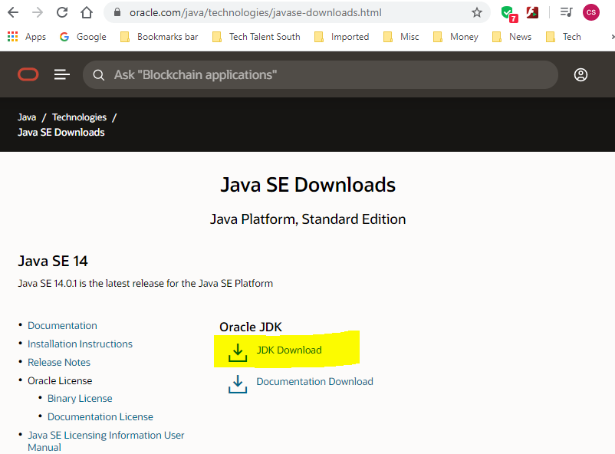

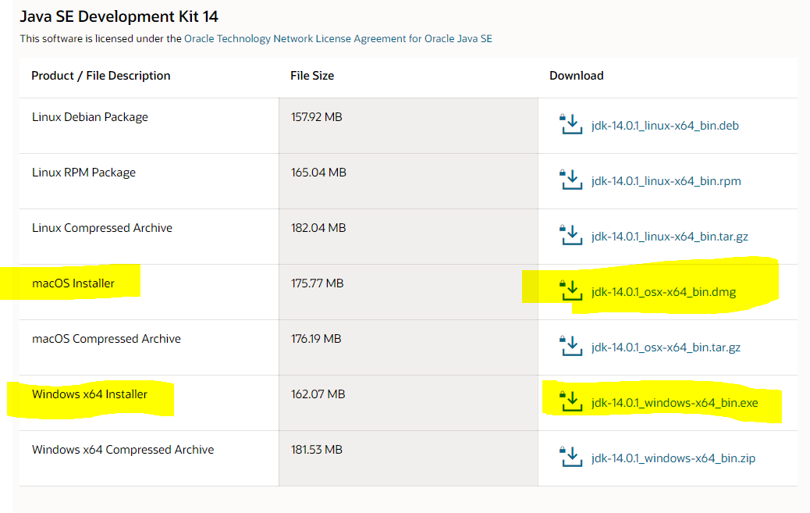

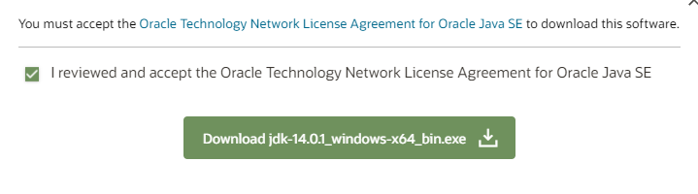

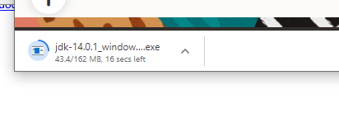

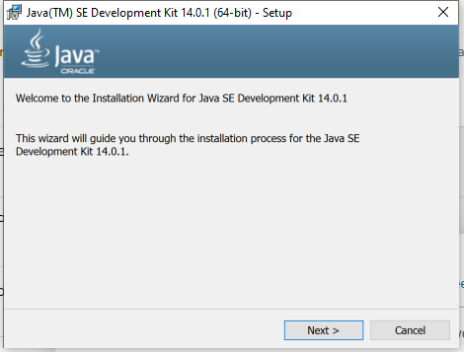

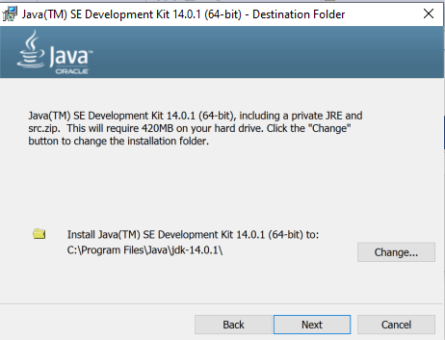

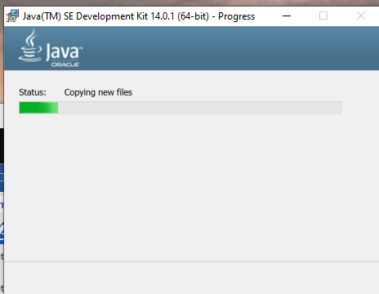

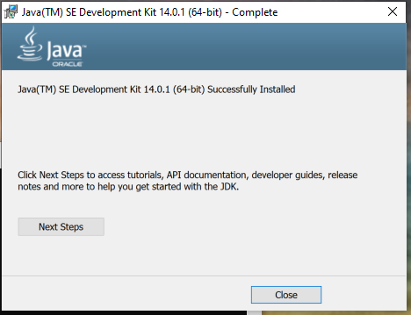

Need to put C:\Program Files\Java\jdk-14.0.1\bin in Environment variable path

Settings > System > Search Environment Variables > Edit System Environment Variables

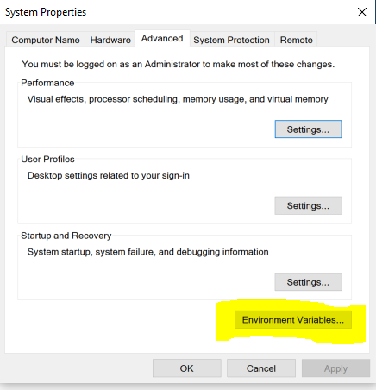

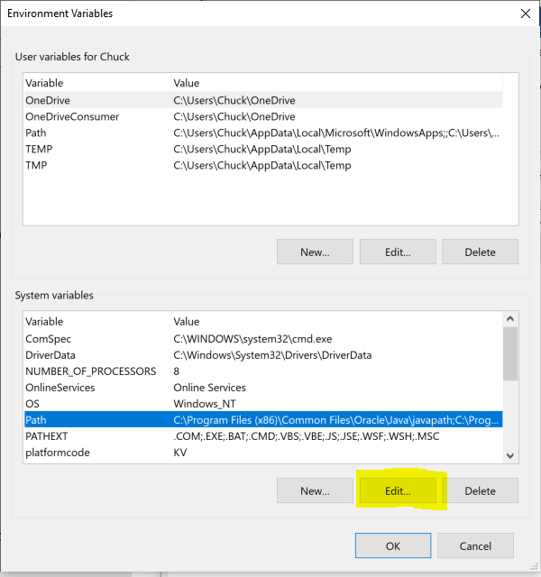

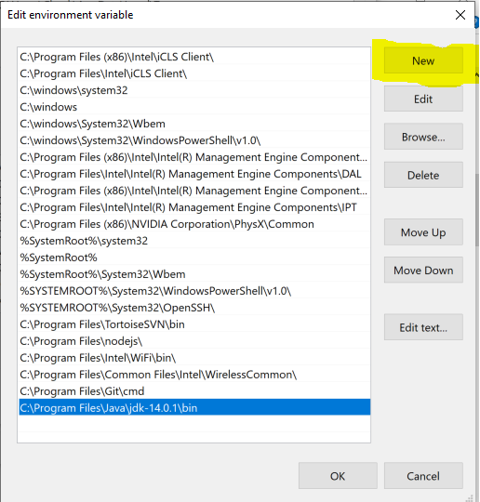

Open NEW command window and check javac -version and java -version

Set JAVA_HOME

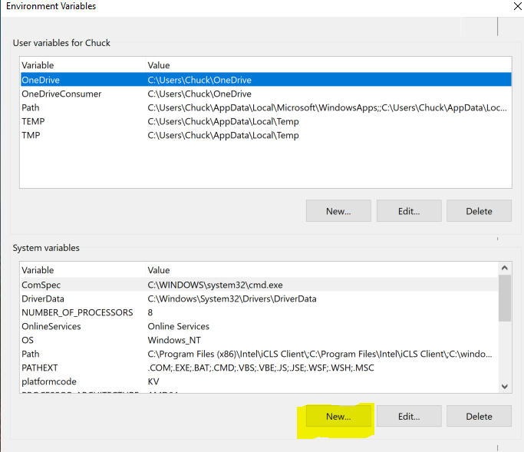

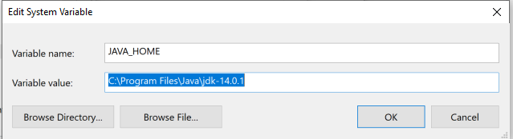

Note: DO NOT INCLUDE THE /bin

Installing on the MAC <https://www.youtube.com/watch?v=sNYvYTmOGhU>

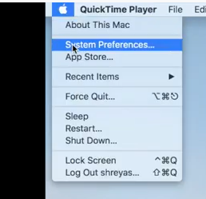

Java icon not present

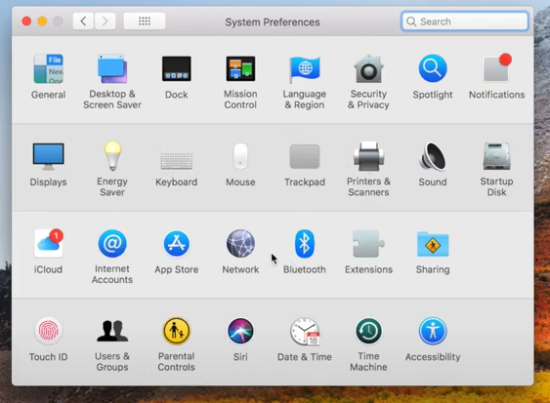

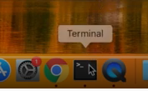

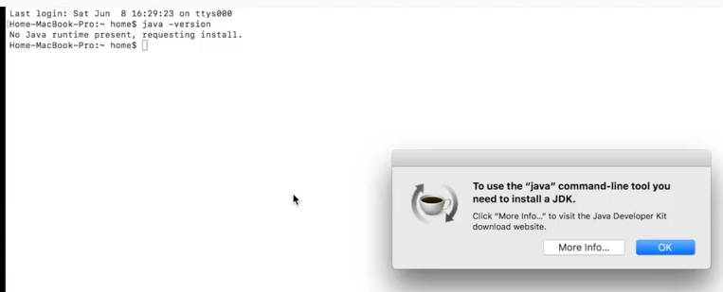

Download same as above

<https://www.oracle.com/java/technologies/javase-downloads.html>

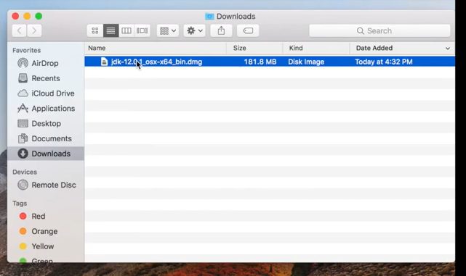

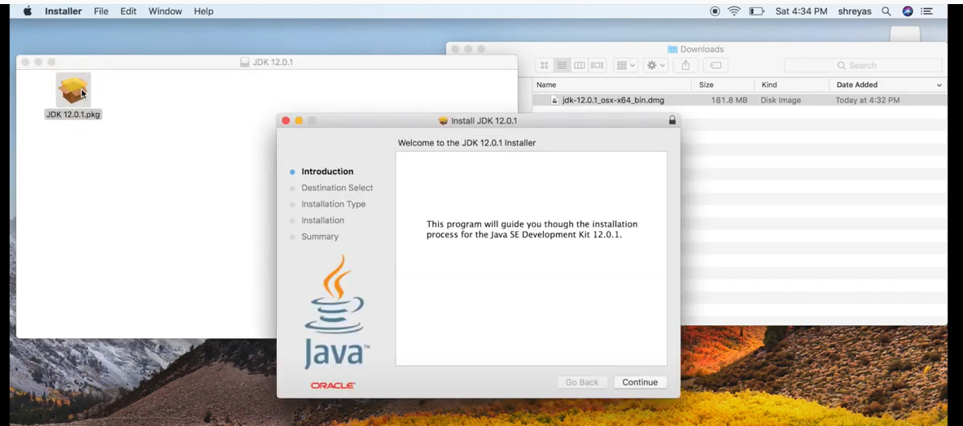

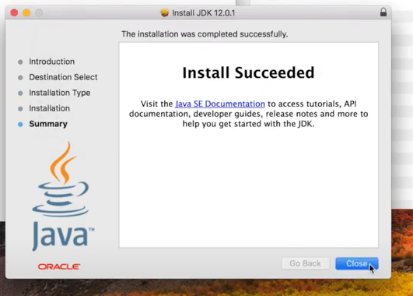



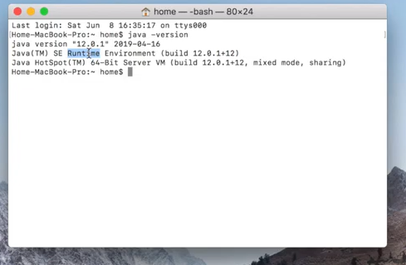

Set JAVA_HOME

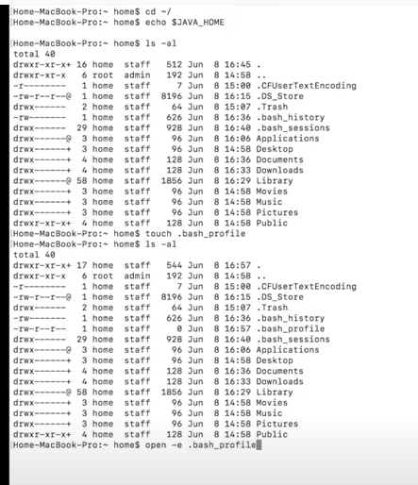

Edit and save the file

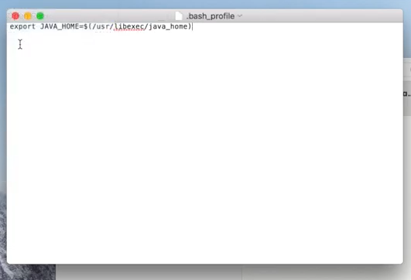

SUCCESS!

